**Listners** : Listeners are TestNG annotations that literally “listen” to the events in a script. It is used in selenium by implementing Listeners Interface.

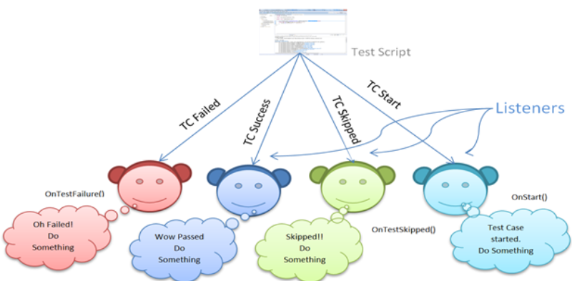

Below are the few TestNG listeners:

1. IAnnotationTransformer
2. IAnnotationTransformer
3. IConfigurable
4. IConfigurationListener
5. IExecutionListene
6. IHookable
7. IInvokedMethodListener
8. IInvokedMethodListener
9. IMethodInterceptor
10. IReporter
11. ISuiteListener
12. ITestListener

How to implement TestNG Listeners :

1. Create new package
2. Create a class that implements ITestListener interface
3. Since we are implementing interface (by class created in above step) we provide body to all methods of interface.
4. Create testing test and add @Listener annotation

Ex. @Listeners(TestNG_Listners.Listener1.class). In case of multiple listeners : give comma separated values : @Listeners({ com.example.MyListener.class, com.example.MyMethodInterceptor.class })

1. Run test and check output

Step 1 : Created a package

Step 2,3 : Create a class that implements ITestListener interface, and provide body to all methods of interface.

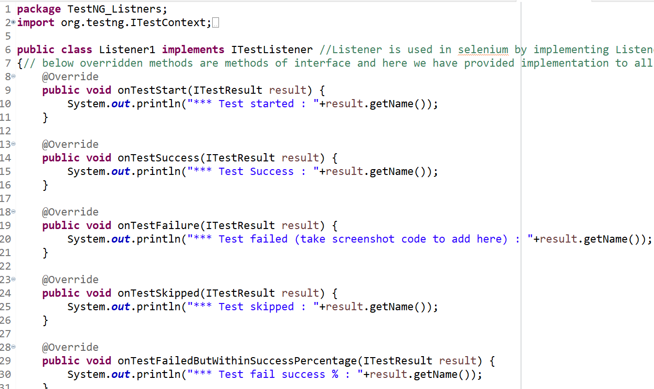

Step 4 : Create testing test and add @Listener annotation

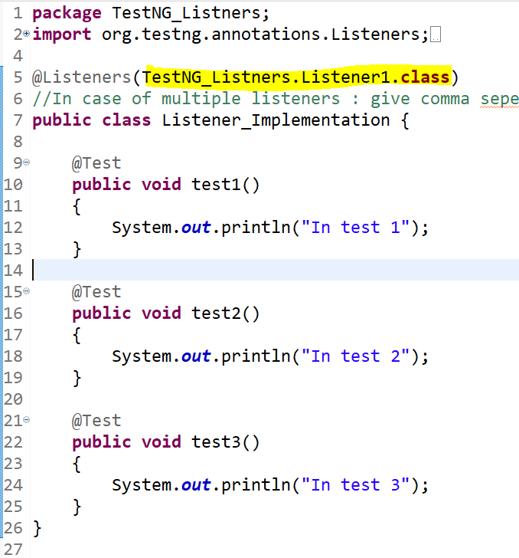

Step 5 : Run test and check output

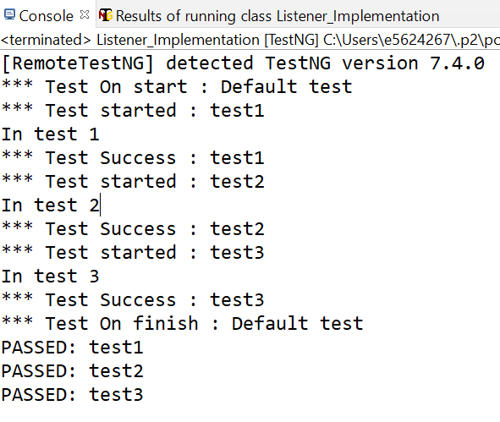

**Failed test output**: Once failed code for onTestFailure() method got executed. We deliberately failed test#2.

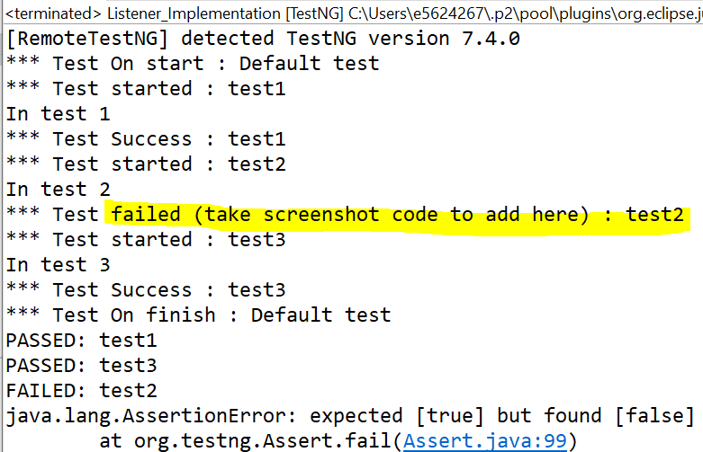

**Skipped test output** : we deliberately skip test#3

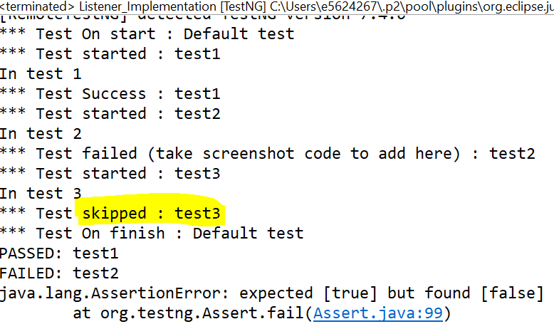

Add listeners at suit level : step :

1. Create testing.xml
2. Define listeners in testing.xml file [below suits tag]

